**Assisted Practice: 3.7 Delete an EBS Volume**

This section will guide you to:

* Delete an EBS volume

This lab has three subsections, namely:

3.7.1 Selecting the EBS volume you want to delete

3.7.2 Deleting the volume

3.7.3 Pushing the file to GitHub repositories

**Step 3.7.1:** Selecting the EBS volume you want to delete

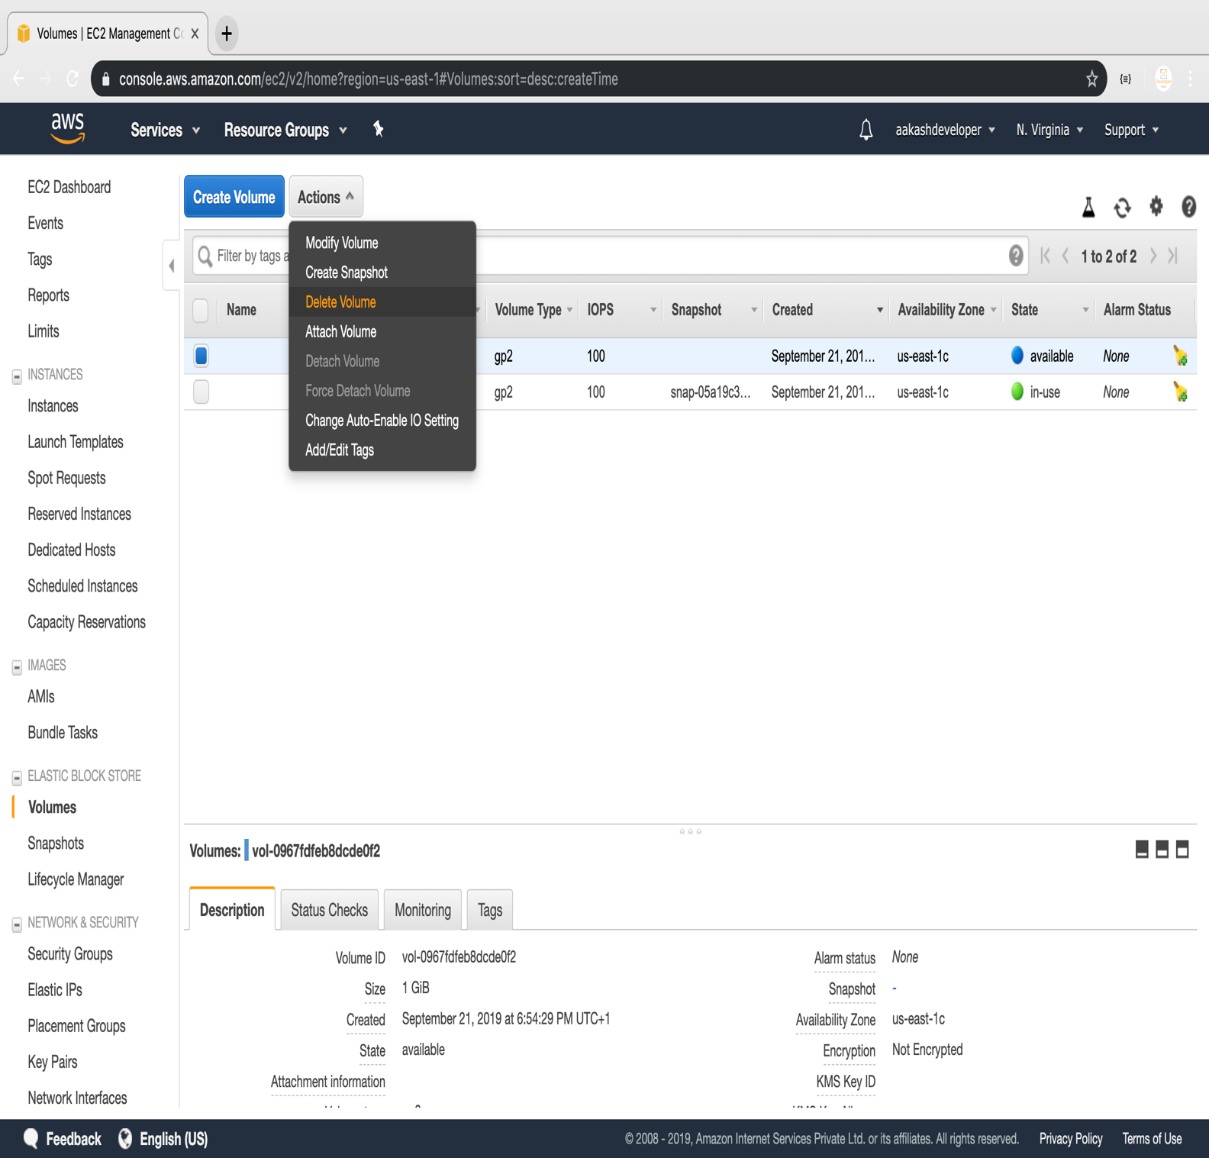

**Step 3.7.2:** Deleting the volume

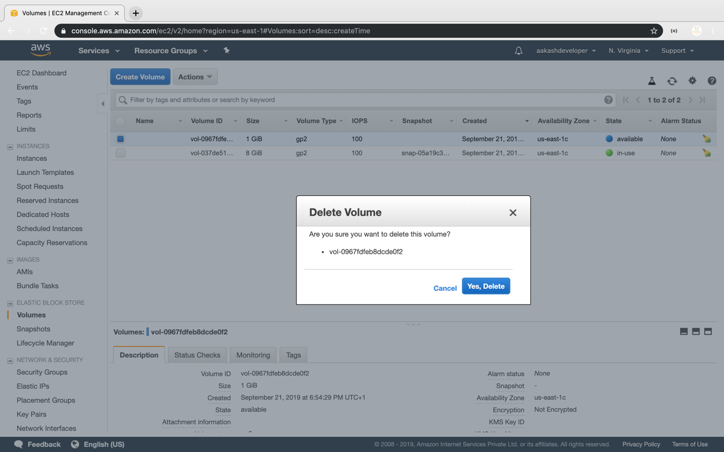

**Step 3.7.3:** Pushing the code to your GitHub repositories

* Open your command prompt and navigate to the folder where you have created your files.

**cd <folder path>**

* Initialize your repository using the following command:

**git init**

* Add all the files to your git repository using the following command:

**git add .**

* Commit the changes using the following command:

**git commit . -m “Changes have been committed.”**

* Push the files to the folder you initially created using the following command:

**git push -u origin master**